**EXP 6)** Create a simple cloud software application for Payroll Processing System using any Cloud Service Provider to demonstrate SaaS include the necessary fields such as Name of the employee, experience in present org , over all experience, basic pay, HRA, DA, TA, net pay, gross pay etc

**PROCEDURE:**

**STEP 1:** GOTO ZOHO.COM

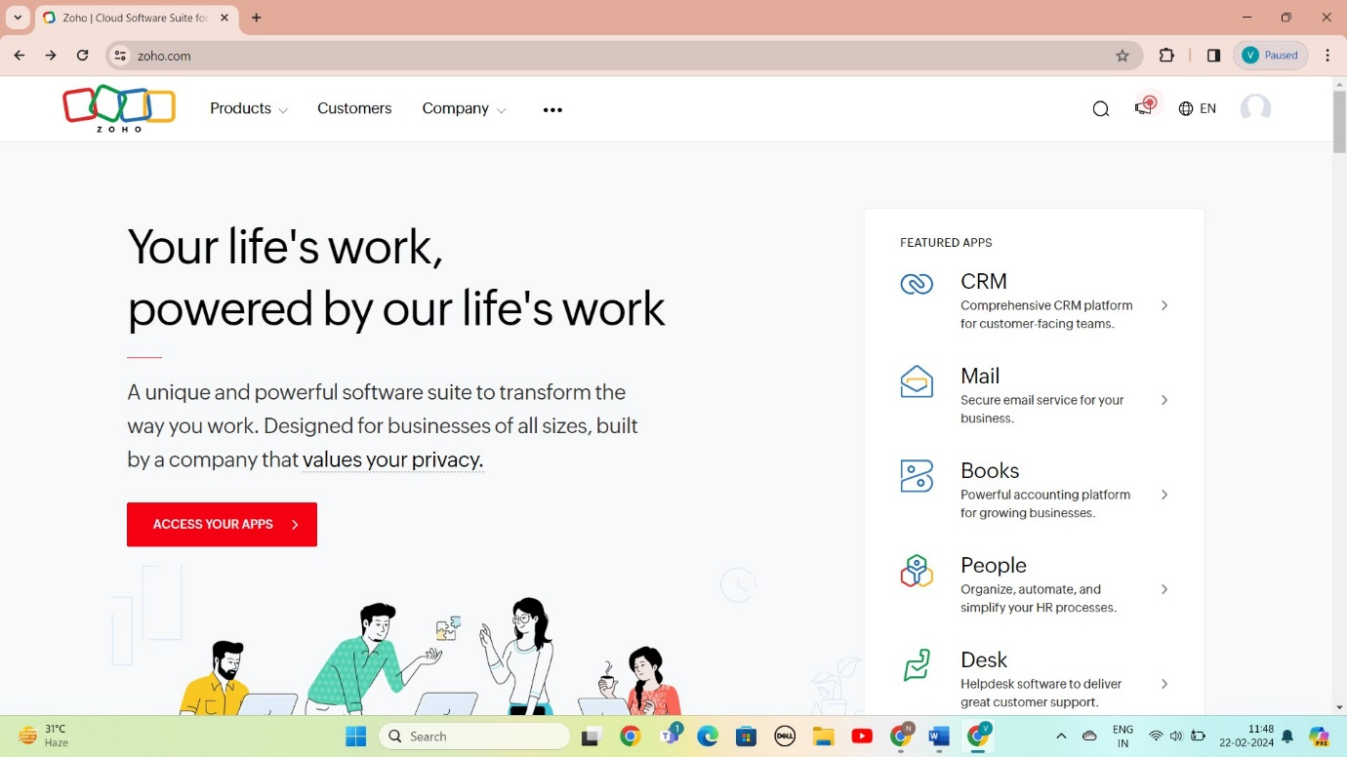

STEP 2: LOGIN TO THE ZOHO.COM

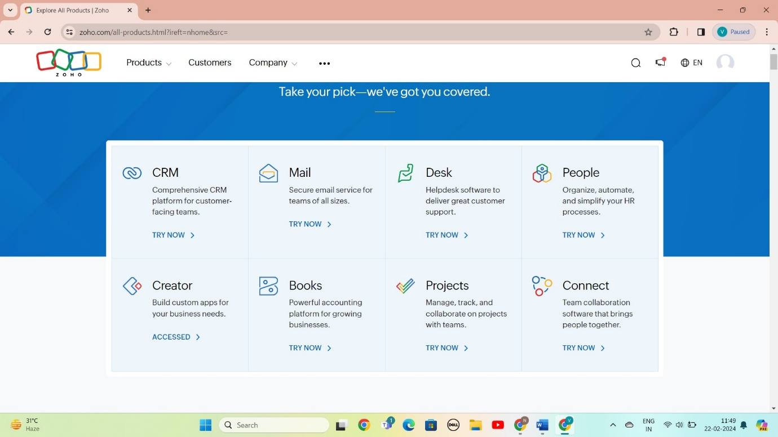

STEP 3: SELECT A CREATE FROM SCRATCH

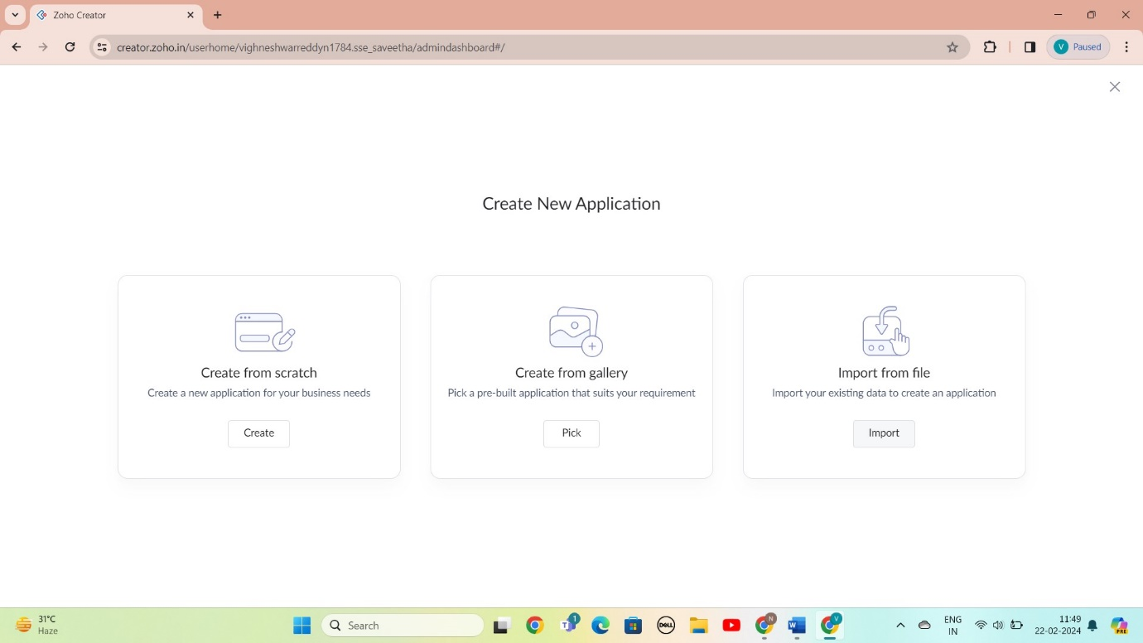

STEP 4: SELECT APPLICATION NAME AS PAYROLL PROCESSING System

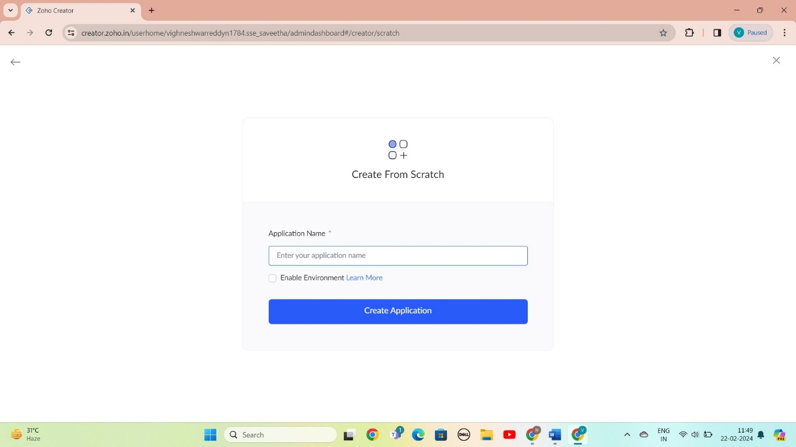

STEP 5: CREATED NEW FORM

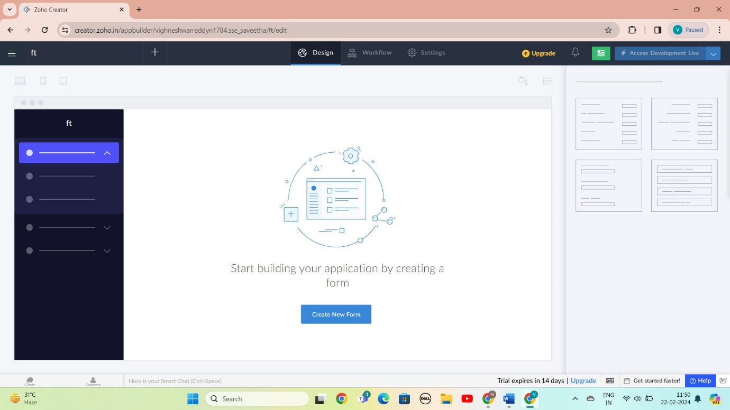

STEP 6: SELECT BASIC FILED FROM GIVEN BELOW AND DEVELOP APPLICATION

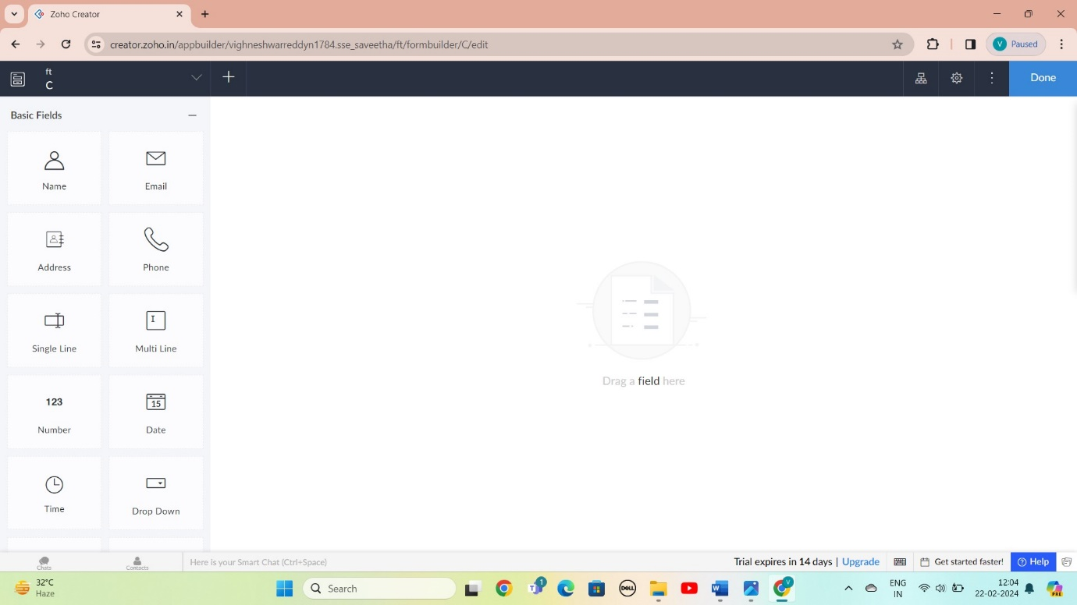

STEP 7: THE SOFTWARE AS BEEN CREATE EMPLOYEE DTAILS

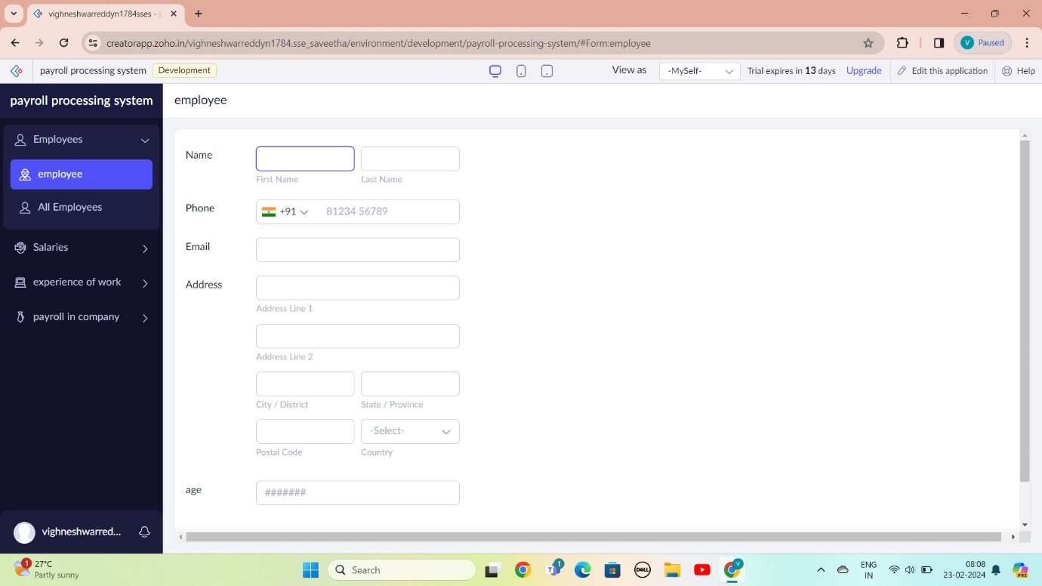

STEP 8: THE SOFTWARE AS BEEN CREATE PAYROLL IN COMPANY

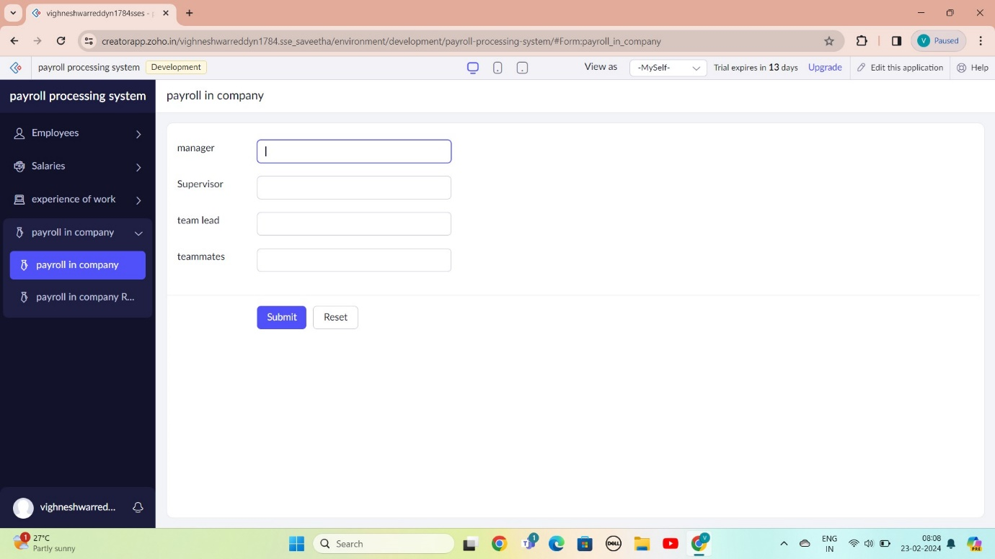

STEP 9: THE SOFTWARE AS BEEN CREATE EXPERIENCE OF WORK

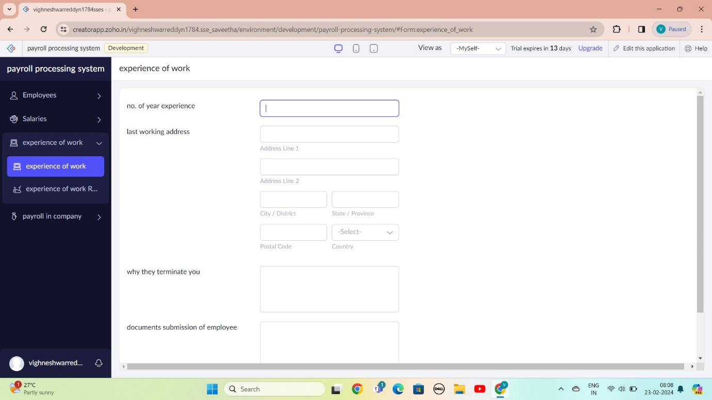

STEP 10: THE SOFTWARE AS BEEN CREATE SALARIES

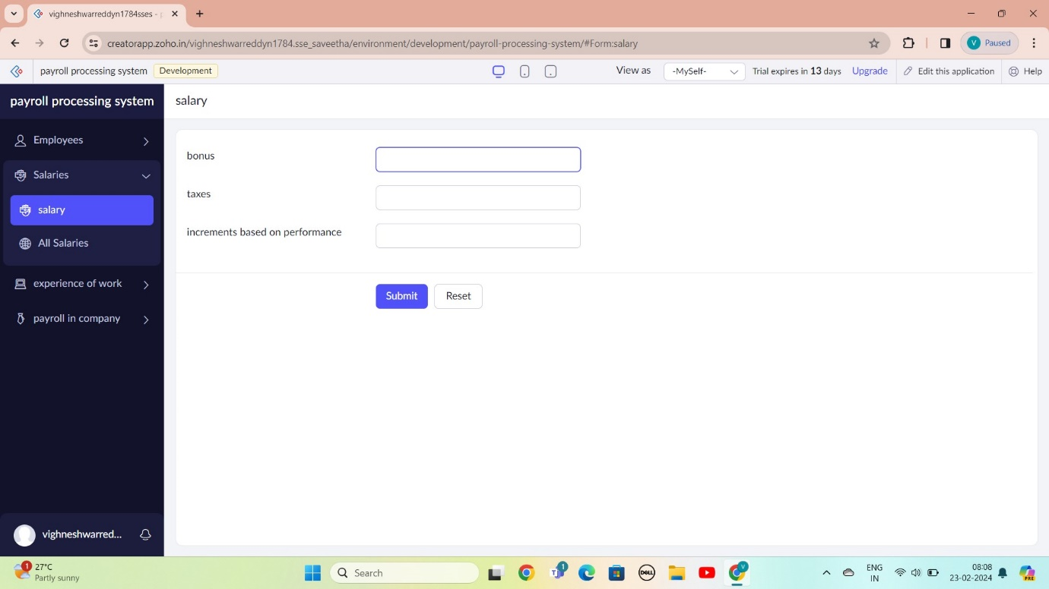

STEP 11: THE SOFTWARE AS BEEN CREATE

